**OPEN ENDED LAB**

**NAME: NOOR FATIMA  
ROLL NO: 21SW062**

**SECTION: II**

**TASK NO: 01**

1-Find the shortest distanceusing Dijkstra algorithm.

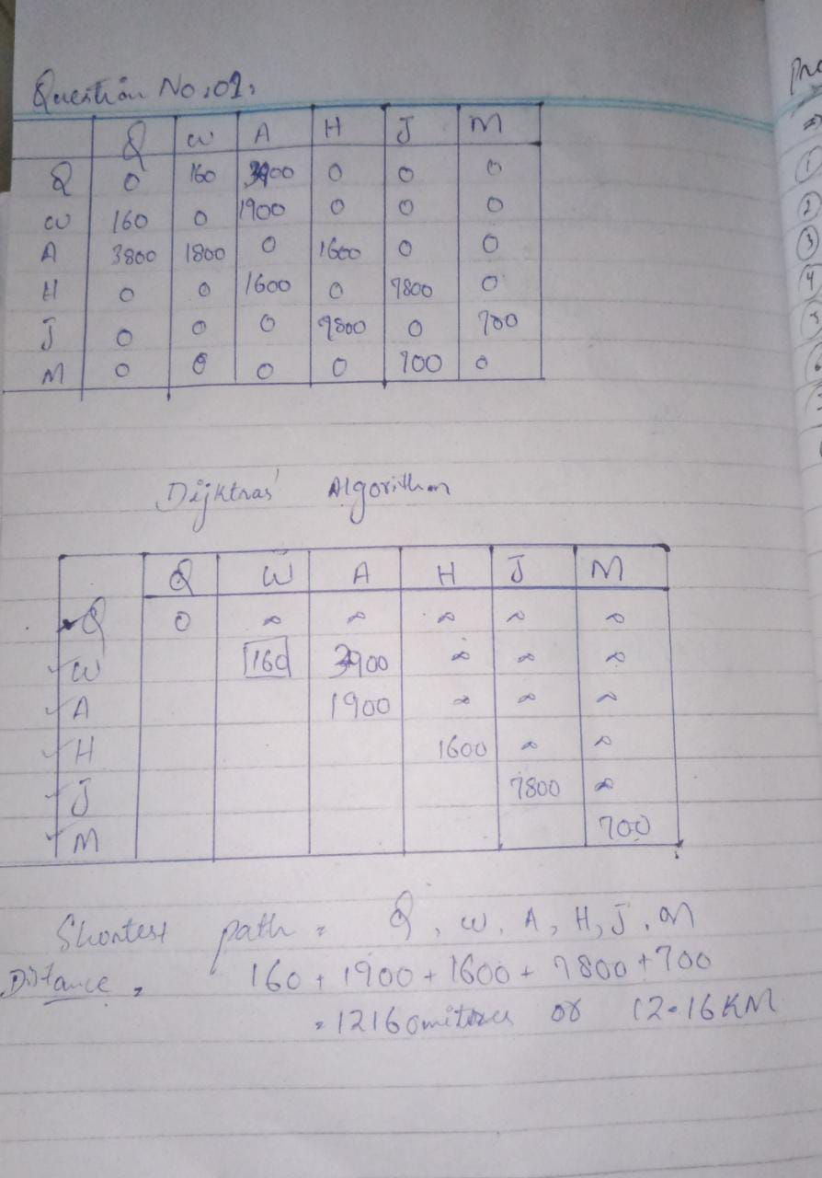

**TASK NO: 02**

2-Design graph of the above scenarioand state which type of graphit is?

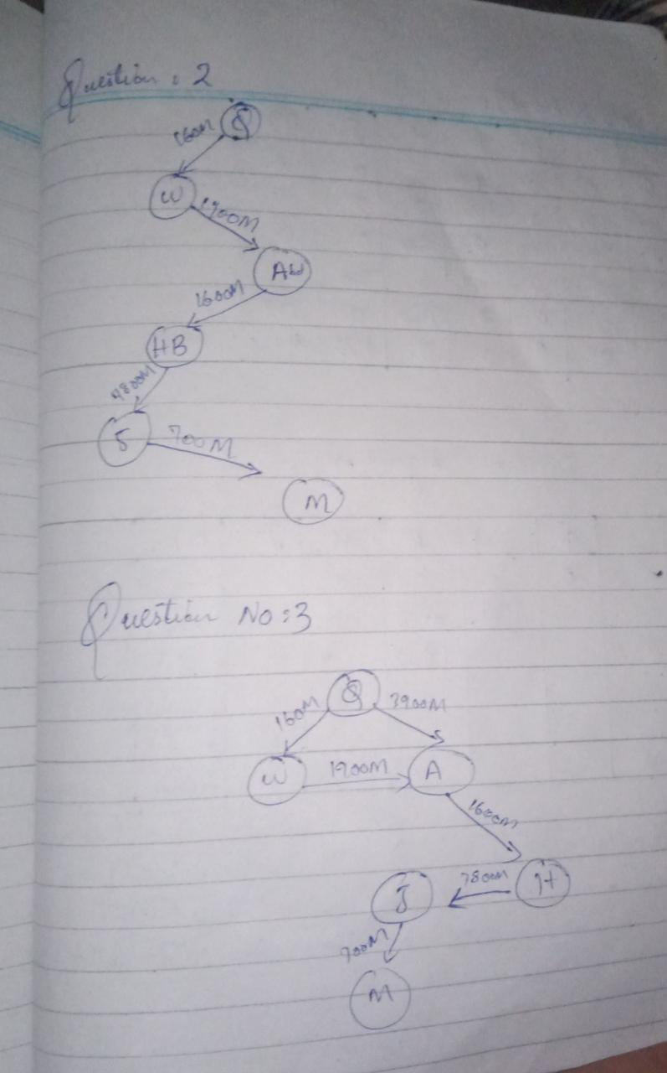

**TASK NO: 03**

3-Represent the graph (designed in task 2)in two possible ways discussed in the class/lab.



**TASK NO: 04**

4-Using a suitable Data Structure, implement the above discussed example in java.

class GRAPH {  
 int size;  
 String[] vertices;  
 boolean[][] a;  
 public GRAPH(String[]args){  
 size=args.length;  
 vertices=new String[size];  
 System.*arraycopy*(args,0,vertices,0,size);  
 a=new boolean[size][size];  
 }  
 public void add(String v,String w){  
 int i=index(v),j=index(w);  
 a[i][j]=a[j][i]=true;  
 }  
 private int index(String v){  
 for(int i=0;i<size;i++)  
 if(vertices[i].equals(v))return i;  
 return size;  
 }  
  
 @Override  
 public String toString() {  
 if(size==0)return "{}";  
 StringBuilder s=new StringBuilder("{ "+vertex(0));  
 for(int i=1;i<size;i++)s.append(", ").append(vertex(i));  
 return s+" }";  
 }  
 private String vertex(int i){  
 StringBuilder s=new StringBuilder(vertices[i]+" : ");  
 for(int j=0;j<size;j++)if(a[i][j])s.append(vertices[j]);  
 return s+"";  
 }  
  
}

class Main{  
 public static void main(String[] args) {  
 String[] s={"Qasimabad","Wadhuwah Rd","Abdullah Mall Rd","Hyderabad Bypass","Jamshoro","MUET Main Gate"};  
 GRAPH g=new GRAPH(s);  
 g.add("Qasimabad","Wadhuwah Rd");  
 g.add("Qasimabad","Abdullah Mall Rd");  
 g.add("Wadhuwah Rd","Abdullah Mall Rd");  
 g.add("Abdullah Mall Rd","Hyderabad Bypass");  
 g.add("Hyderabad Bypass","Jamshoro");  
 g.add("Jamshoro","MUET Main Gate");  
 System.*out*.println(g);  
 }  
}

**OUTPUT:**

"C:\Program Files\Java\jdk-17.0.2\bin\java.exe" "-javaagent:C:\Program Files\JetBrains\IntelliJ IDEA Community Edition 2022.1\lib\idea_rt.jar=56554:C:\Program Files\JetBrains\IntelliJ IDEA Community Edition 2022.1\bin" -Dfile.encoding=UTF-8 -classpath C:\Users\hp\IdeaProjects\DSA_ALL_LABS\out\production\DSA_ALL_LABS Main  
 { Qasimabad : Wadhuwah RdAbdullah Mall Rd, Wadhuwah Rd : QasimabadAbdullah Mall Rd, Abdullah Mall Rd : QasimabadWadhuwah RdHyderabad Bypass, Hyderabad Bypass : Abdullah Mall RdJamshoro, Jamshoro : Hyderabad BypassMUET Main Gate, MUET Main Gate : Jamshoro }  
  
 Process finished with exit code 0

**TASK NO: 05**

5-Write-downyourday-to-dayreal-lifeapplication of graph.

